To change the permission levels, change permissions, reset the SAS key and then update key in bricks code, execue the boiler code again.

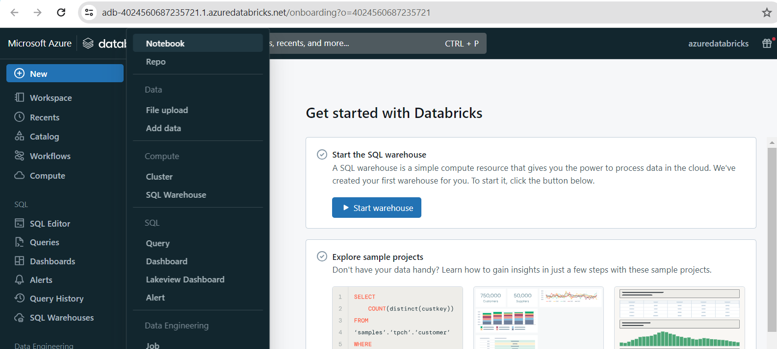

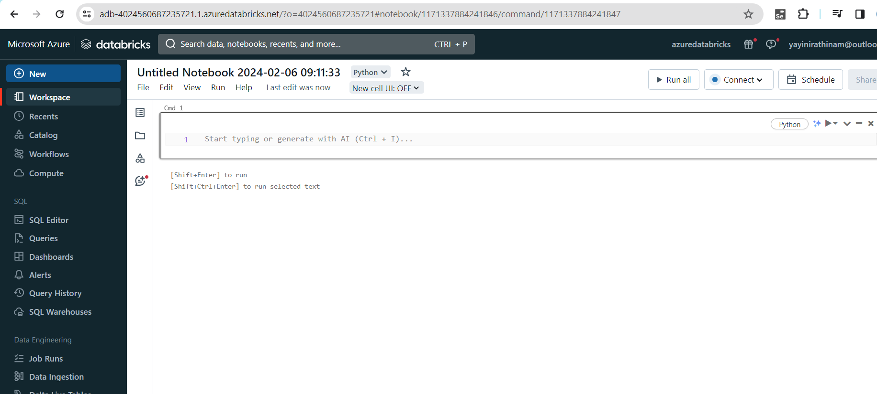

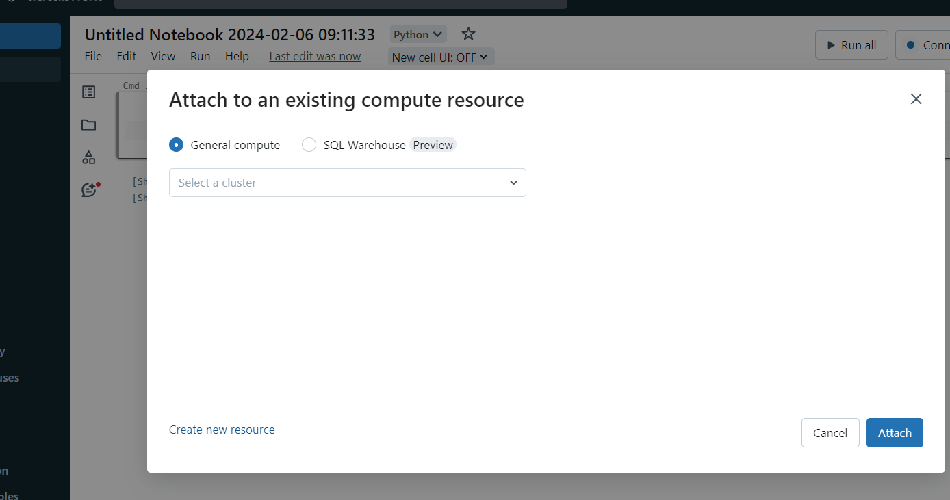

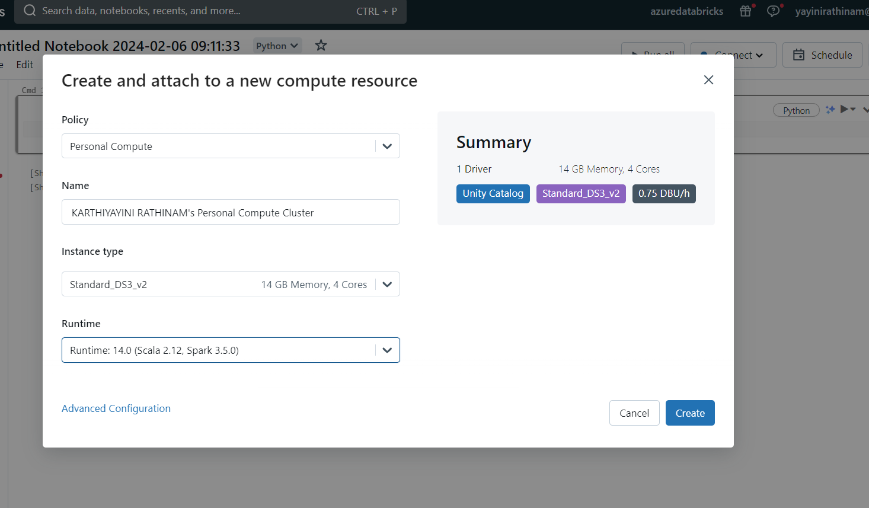

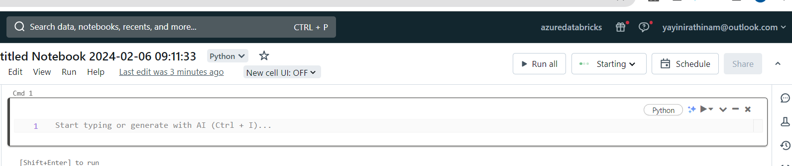

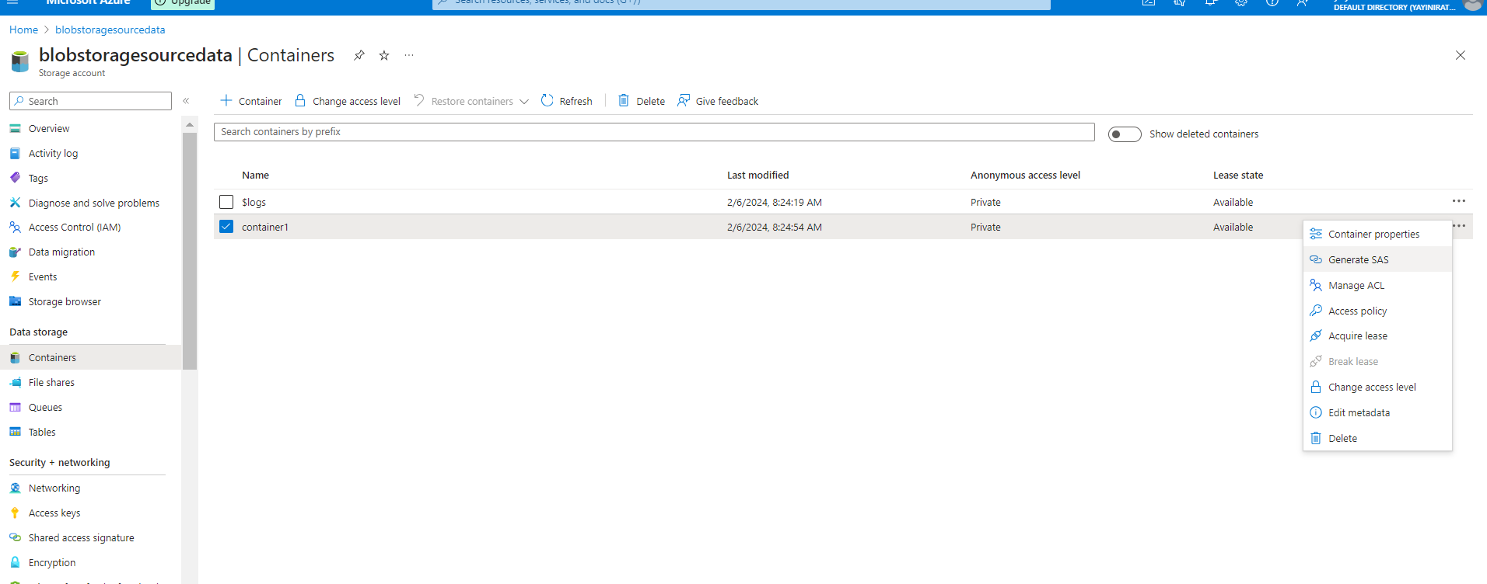

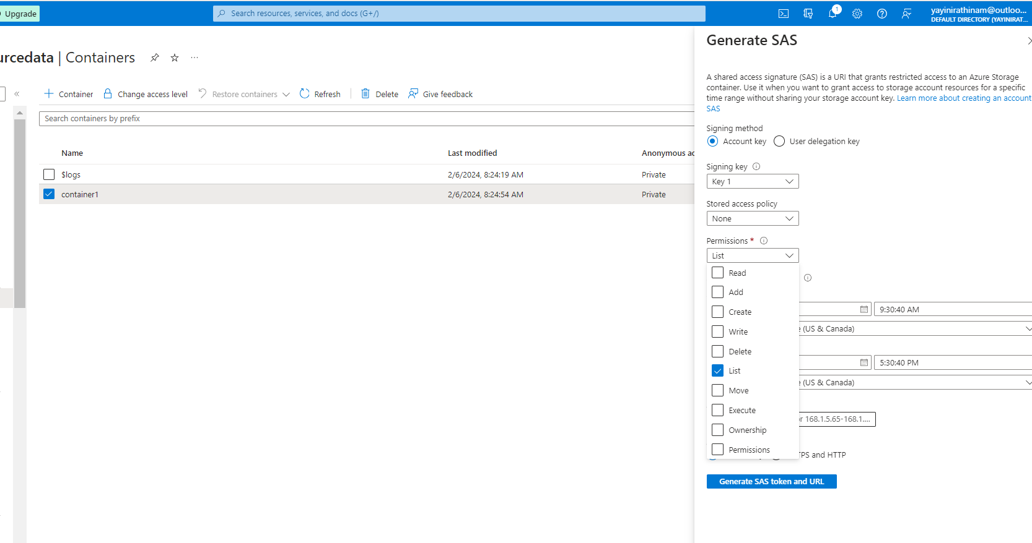

sp=rl&st=2024-02-06T16:30:17Z&se=2024-02-07T00:30:17Z&spr=https&sv=2022-11-02&sr=c&sig=mY9LQ8jgf%2BCuEzZIz%2F9p2wzEW4EcmvaNUdBUWggFJMM%3D

sp=rl&st=2024-02-06T16:41:19Z&se=2024-02-07T00:41:19Z&spr=https&sv=2022-11-02&sr=c&sig=0sP%2BO9zKHt9Iv544bE1xu1Plrb24LeVVAidkn5Iw1tM%3D

sp=rl&st=2024-02-06T16:30:17Z&se=2024-02-07T00:30:17Z&spr=https&sv=2022-11-02&sr=c&sig=mY9LQ8jgf%2BCuEzZIz%2F9p2wzEW4EcmvaNUdBUWggFJMM%3D

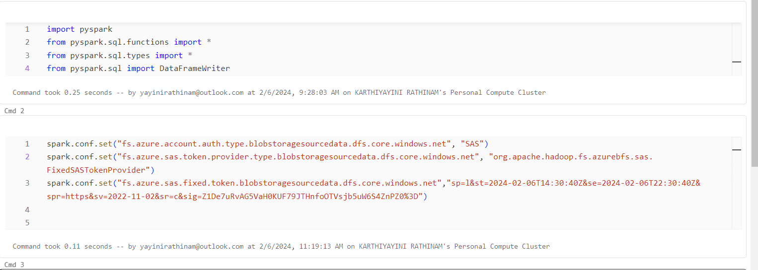

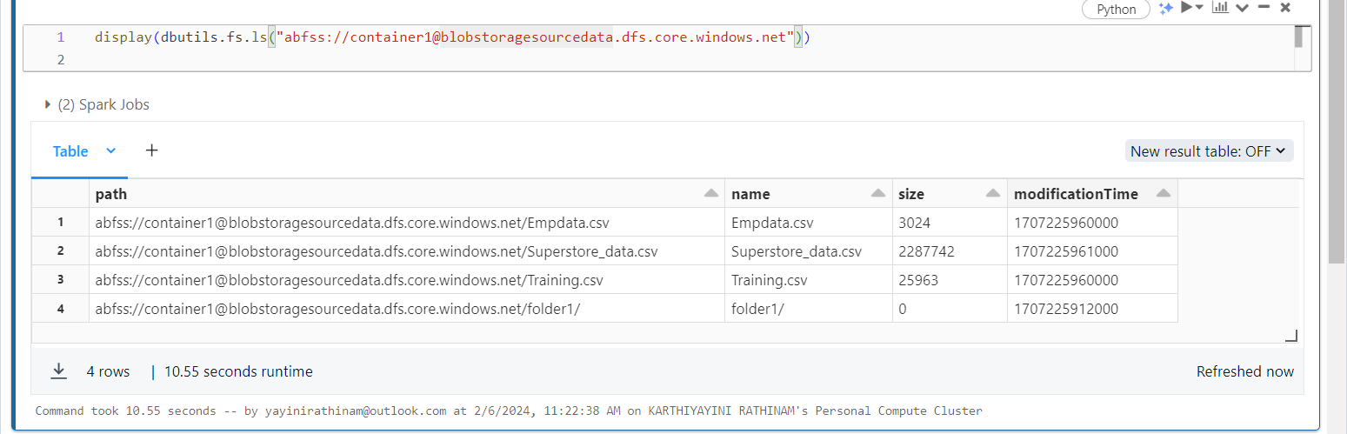

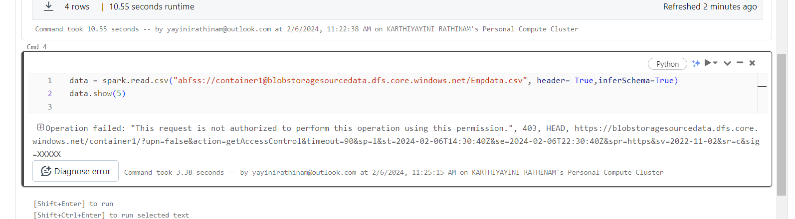

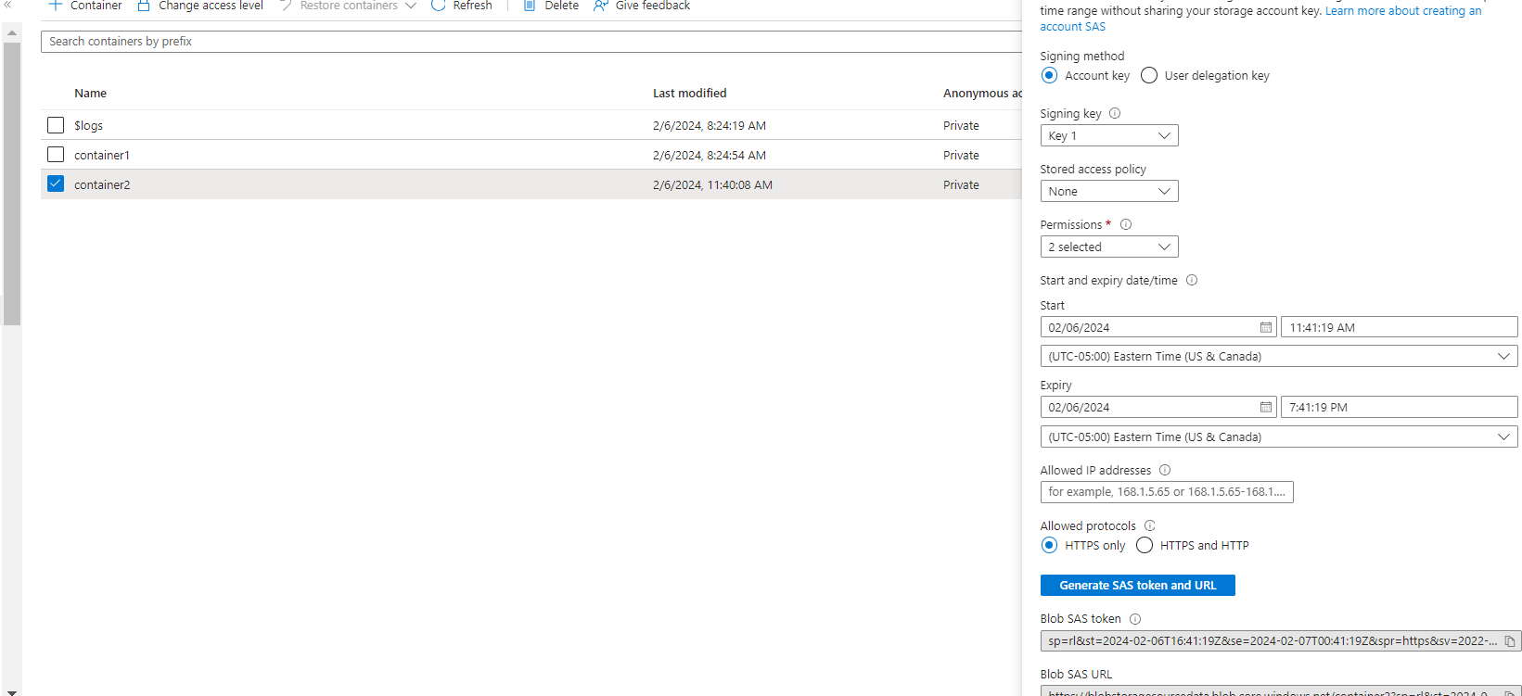

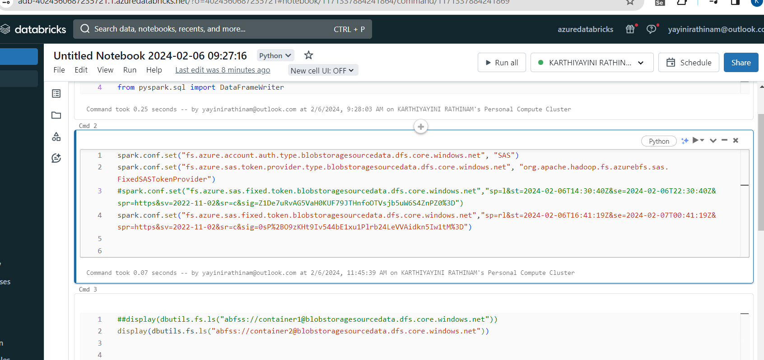

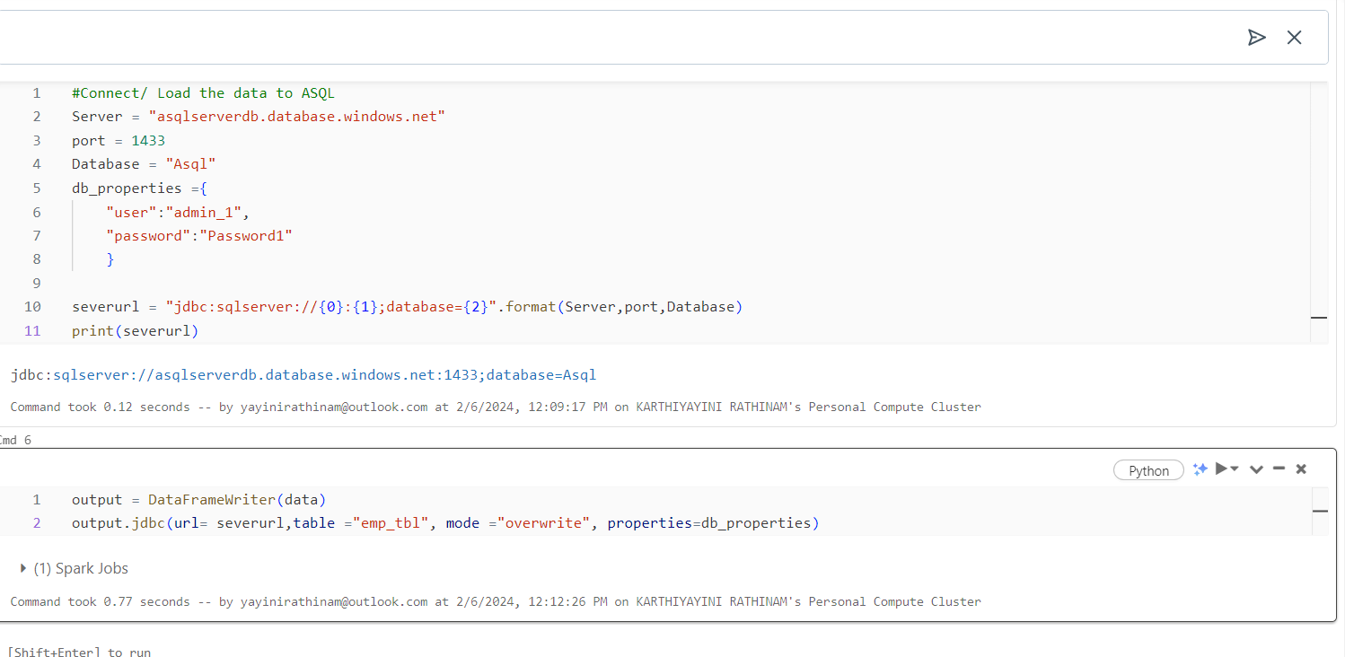

sp=r&st=2024-02-06T17:34:52Z&se=2024-02-07T01:34:52Z&spr=https&sv=2022-11-02&sr=c&sig=0nq4ERZhtN6Bd2KBOaPnOx9tY1QTgBUynxTfdmH4%2FUM%3D 